Assignment #2: COMP 228

Student: Jordan Hubscher, ID: 7019696

Professor: Todd Eavis

Due Date: February 16th, 2014

1.

a) F(q,r,s,t) = (rs’ + q’t)(qr’ + st’)

qr’(rs’ + q’t) + st’(rs’ + q’t)

(qr’rs’ + qr’q’t) + (st’rs’ + st’q’t)

(0 + 0) + (0 + 0)

**Answer: 0**

b) F(q,r) = (q + r)’(q’ + r’)’

(q’r’)(qr)

(00)

**Answer: 0**

c) F(q,r,s) = q’(r’s + rs) + qrs

q’r’s + q’rs + qrs

q’s(r’ + r) + qrs

q’s(1) + qrs

**Answer: s(q’ + qr)**

2.

a)

|  |  |  |  |  |
| --- | --- | --- | --- | --- |
| **x** | **y** | **x’** | **xy** | **xy + x’** |
| 0 | 0 | 1 | 0 | 1 |
| 0 | 1 | 1 | 0 | 1 |
| 1 | 0 | 0 | 0 | 0 |
| 1 | 1 | 0 | 1 | 1 |

b)

|  |  |  |  |  |  |  |  |  |  |  |  |  |
| --- | --- | --- | --- | --- | --- | --- | --- | --- | --- | --- | --- | --- |
| **x** | **y** | **z** | **x’** | **y’** | | **z’** | **xyz** | **xx’z’** | **x’yz’** | **x’z** | | **(xyz)+(xx'z')+(x'yz')+(x'z)** |
| 0 | 0 | 0 | 1 | 1 | | 1 | 0 | 0 | 0 | 0 | | 0 |
| 0 | 1 | 0 | 1 | 0 | | 1 | 0 | 0 | 1 | 0 | | 1 |
| 0 | 0 | 1 | 1 | 1 | | 0 | 0 | 0 | 0 | 1 | | 1 |
| 0 | 1 | 1 | 1 | 0 | | 0 | 0 | 0 | 0 | 0 | | 0 |
| 1 | 0 | 0 | 0 | 1 | | 1 | 0 | 0 | 0 | 0 | | 0 |
| 1 | 1 | 0 | 0 | 0 | | 1 | 0 | 0 | 0 | 0 | | 0 |
| 1 | 0 | 1 | 0 | 1 | | 0 | 0 | 0 | 0 | 0 | | 0 |
| 1 | 1 | 1 | 0 | | 0 | 0 | 1 | 0 | 0 | 0 | 1 | |

3.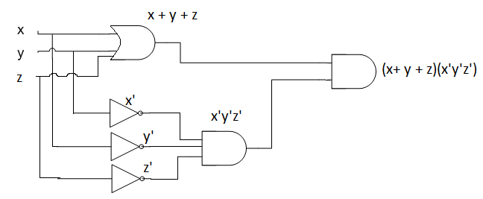

4.

a) x’yz’, x’yz, xyz’, xyz => **Answer: x’yz’ + x’yz + xyz’ + xyz**

b) x’yz’ + x’yz + xyz’ + xyz

x’y(z’ + z) + xy(z’ + z)

x’y(1) + xy(1)

x’y + xy

y(x’ + x)

y(1)

**Answer: y**

5.

a) 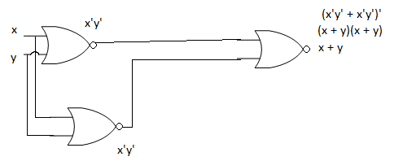

b)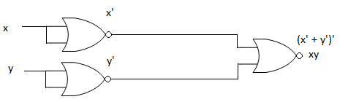

6.

|  |  |  |  |  |  |  |  |  |  |  |
| --- | --- | --- | --- | --- | --- | --- | --- | --- | --- | --- |
| **X** | | **M** | **N** | **X NAND M** | **J** | **K** | **Next M** | **N’** | **N’ NAND M(D)** | **Next N** |
| 1 | | 1 | 1 | 0 | 0 | 0 | 1 | 0 | 1 | 1 |
| 1 | | 1 | 0 | 0 | 0 | 0 | 1 | 1 | 0 | 0 |
| 1 | | 0 | 1 | 1 | 1 | 1 | 1 | 0 | 1 | 1 |
| 1 | | 0 | 0 | 1 | 1 | 1 | 1 | 1 | 1 | 1 |
| 0 | | 1 | 1 | 1 | 1 | 1 | 0 | 0 | 1 | 1 |
| 0 | | 1 | 0 | 1 | 1 | 1 | 0 | 1 | 0 | 0 |
| 0 | | 0 | 1 | 1 | 1 | 1 | 1 | 0 | 1 | 1 |
| 0 | 0 | | 0 | 1 | 1 | 1 | 1 | 1 | 1 | 1 |